GIS/Spatial Analysis Lab #2
Downloads Software: QGIS 2.34 (use QGIS Desktop) - Lab 2 ﬁle: Census tracts (tl_2022_9_tract, tl_2022_34_tract, and tl_2022_36_tract, and accompanying files R50089824_SL140_ct_revised.csv, R50089812_SL140_nj_revised.csv, and R50089810_SL140_ny_revised.csv with CT, NJ, and NY). You can ignore other files and follow along on the video but remember to use the ideas with these files in mind.
Part 1: Loading Data into QGIS
- Load Census Tract Shapefiles for New York, New Jersey, and Connecticut:
  - Open QGIS.
  - Load the shapefiles for census tracts from New York, New Jersey, and Connecticut using Layer > Add Layer > Add Vector Layer.

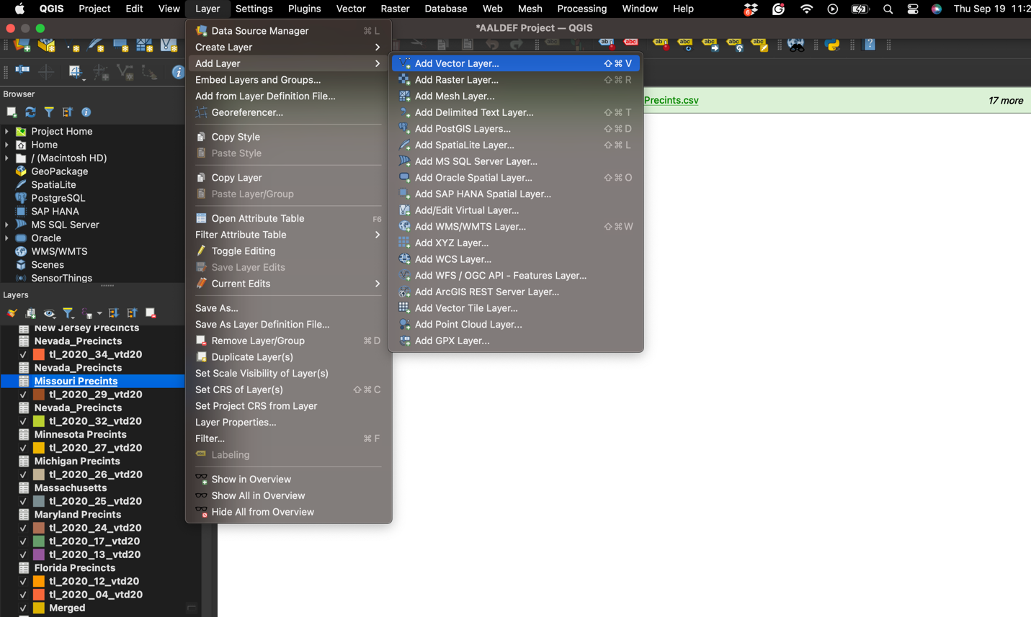
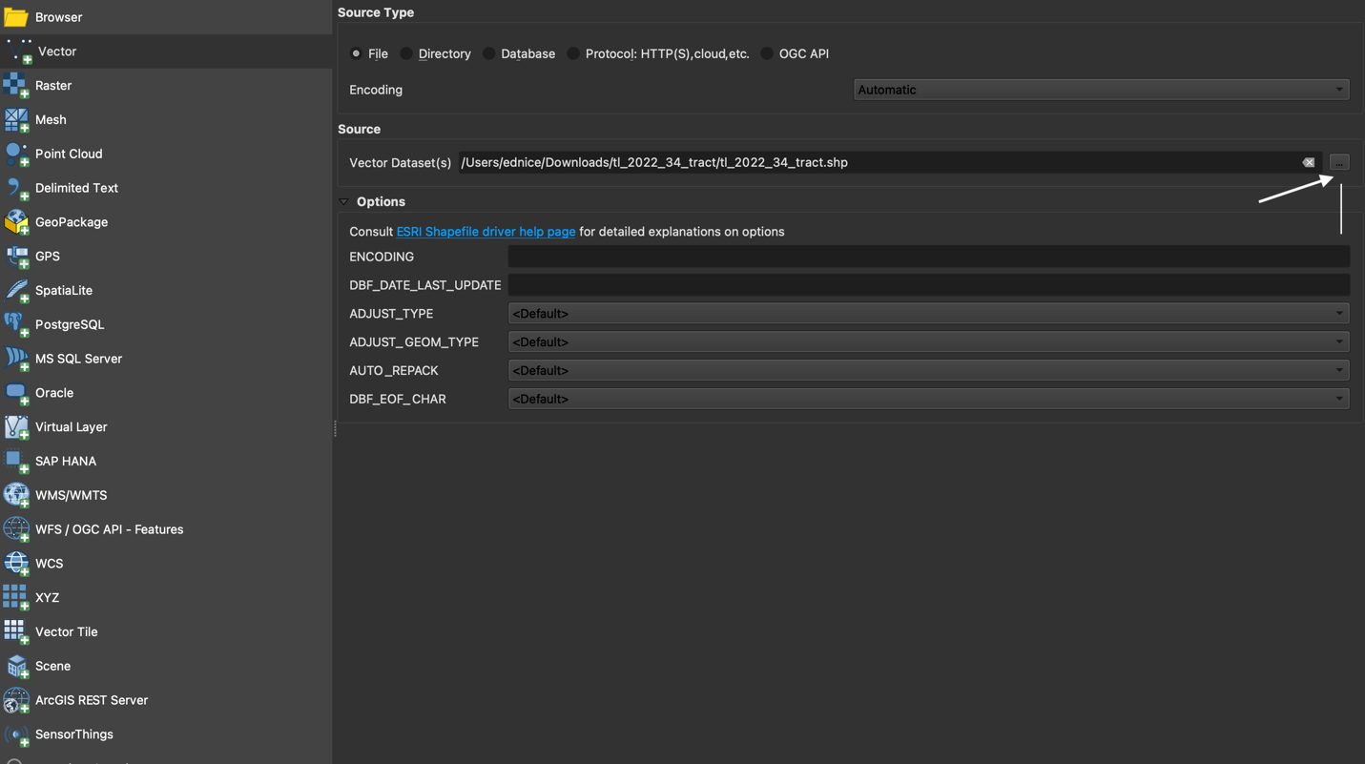
  - Inspect the attributes table to ensure each census tract shapefile includes a column with tract GEOID codes by using Properties > Attribute Table.
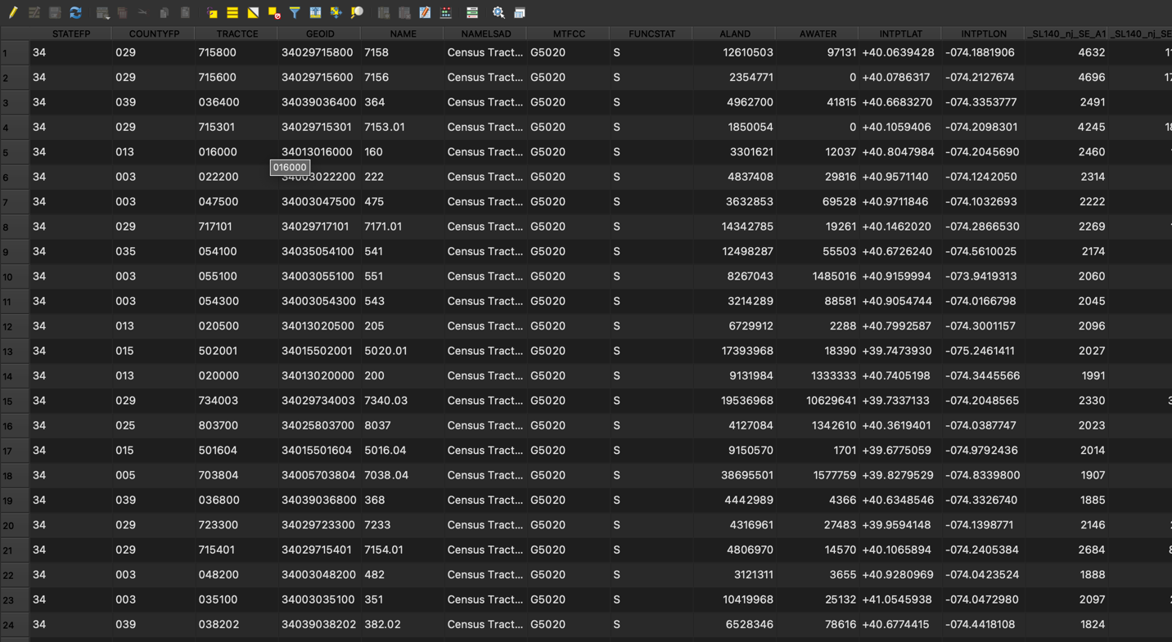
- Load the CSV with Poverty Data into QGIS
  - Load the CSV or database files containing poverty rate data from the ACS (the files with CT, NJ and NY).

  - Confirm that the poverty data includes columns for state FIPS, tract FIPS, and poverty rates.
  - Open the CSV file containing poverty data in a spreadsheet program (like Excel) to inspect it. These files are labeled R50089824_SL140_ct_revised.csv, R50089812_SL140_nj_revised.csv, and R50089810_SL140_ny_revised.csv
  - Ensure that it includes columns for:
    - State FIPS: The two-digit code representing the state.
    - Tract FIPS: The unique code for each census tract.
    - Poverty Rate: The poverty rate percentage for each tract. (note that some files will a different name for the poverty rate because of the Census).
  - Ensure that the Tract FIPS codes in the CSV match the format of the Tract FIPS in the shapefiles.
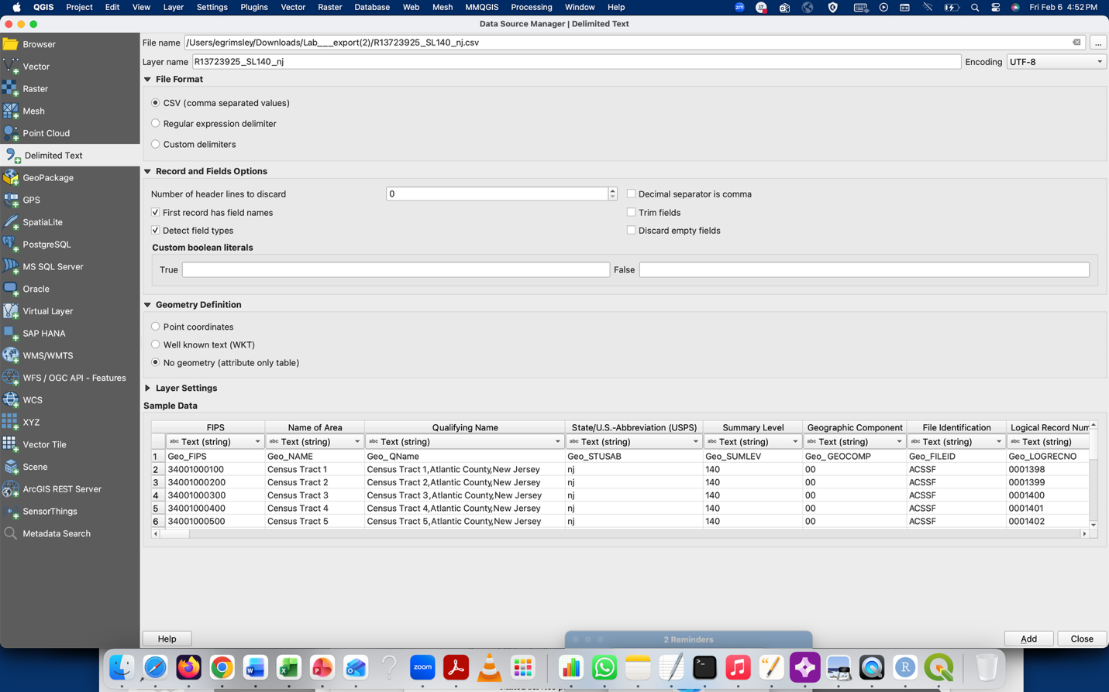
- Add the CSV File to QGIS (for the remaining files):
  - In QGIS, go to Layer > Add Layer > Add Delimited Text Layer.
  - In the dialog box, click Browse and navigate to the location of your CSV file.
  - Select the CSV file and click Open.
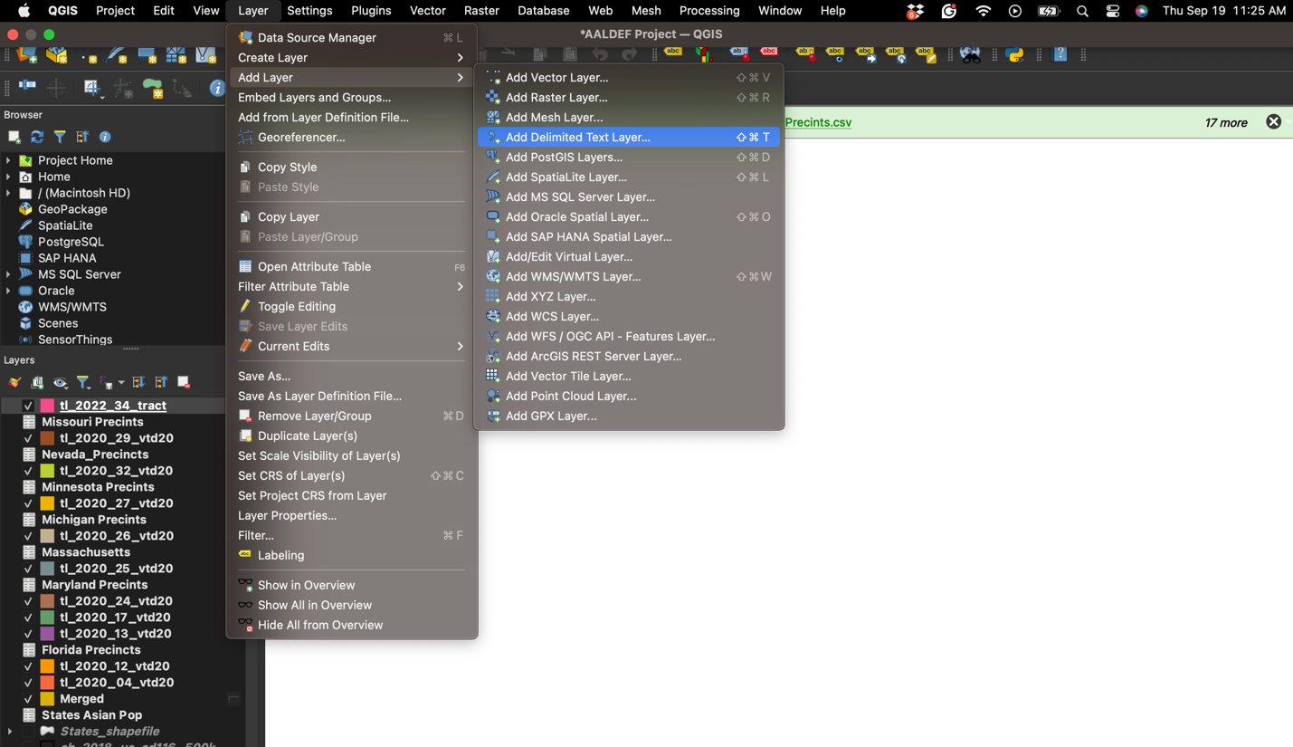
- Configure the CSV File:
  - In the File format section, QGIS will automatically detect the type of file (in this case, CSV).
  - In the Layer Options, ensure that the First record has field names checkbox is selected if the first row of your CSV contains column headers.
  - In the Geometry Definition section, since the CSV file does not contain geographic coordinates, select No geometry (attribute only table). This will add the data as a table, not as a spatial layer.
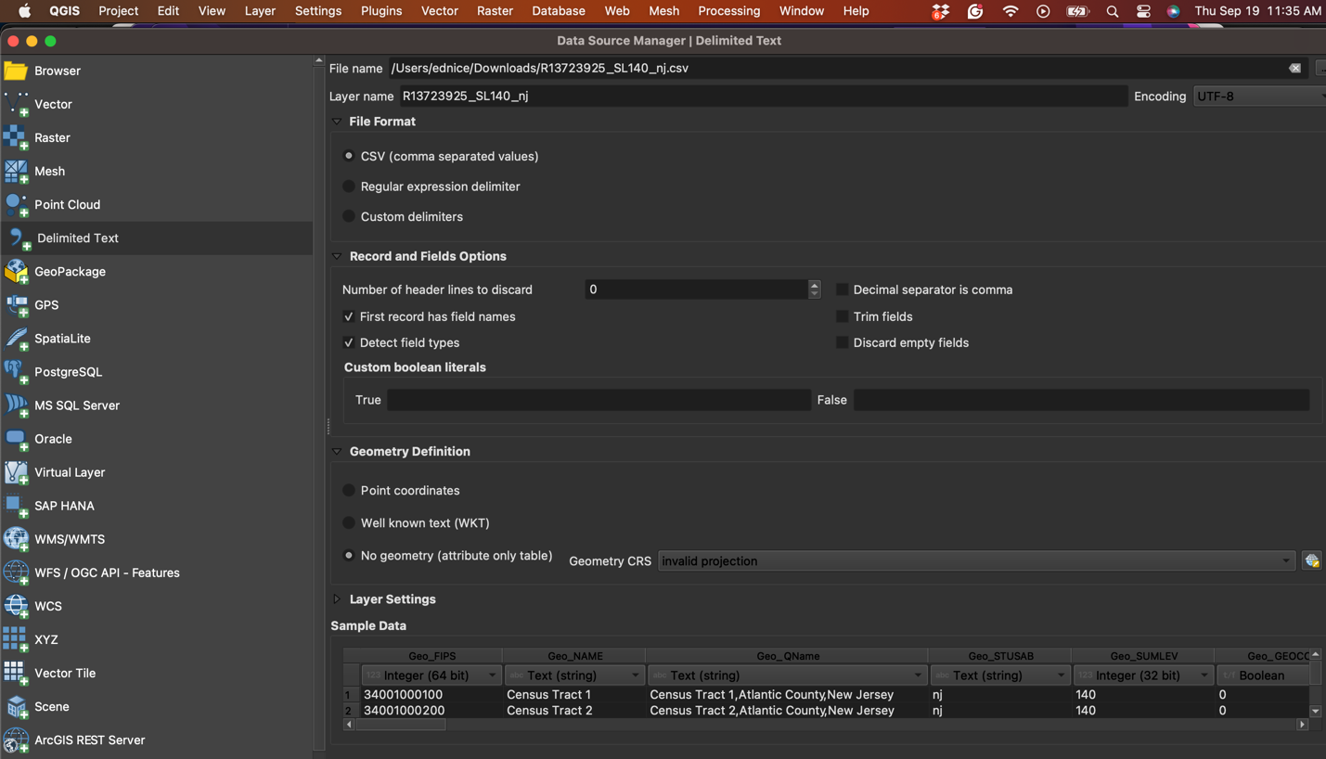
- Load the CSV File:
  - Click Add, and then click Close.
  - The CSV file will now appear as a non-spatial table in the Layers panel of QGIS.
Note: UTF-8 is the preferred format: The most widely used and recommended encoding, especially for datasets that include international characters. It handles most characters from different languages and special symbols.
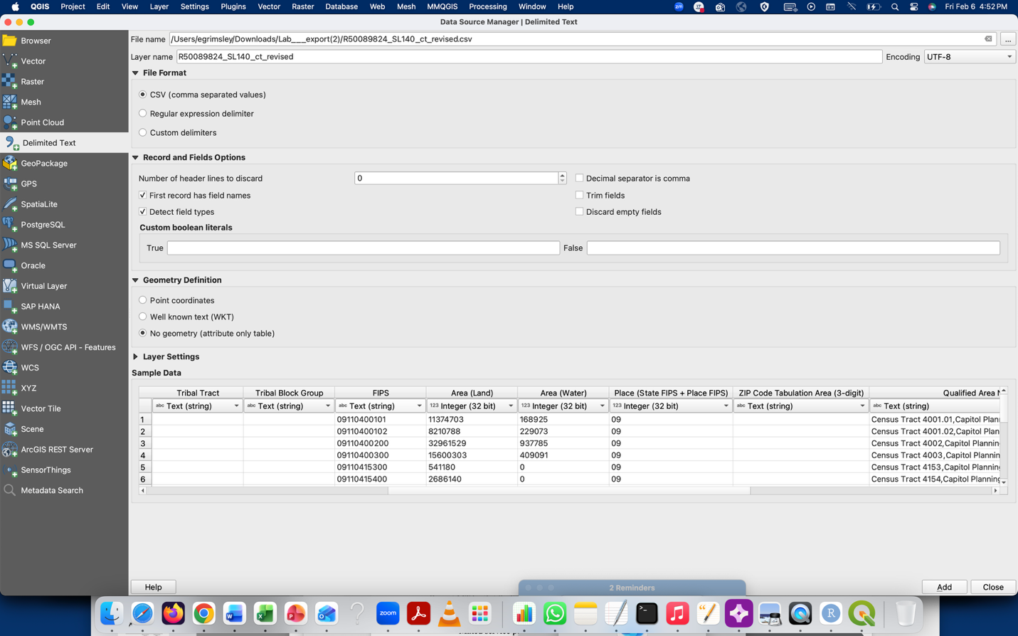
Part 2: Joining Poverty Data (for each state)
- Prepare for Joining Poverty Data:
  - Check that the Poverty rate data has a common identifier (the census tract GEOID to the GEO_FIPS code) matching the merged census tract shapefile.

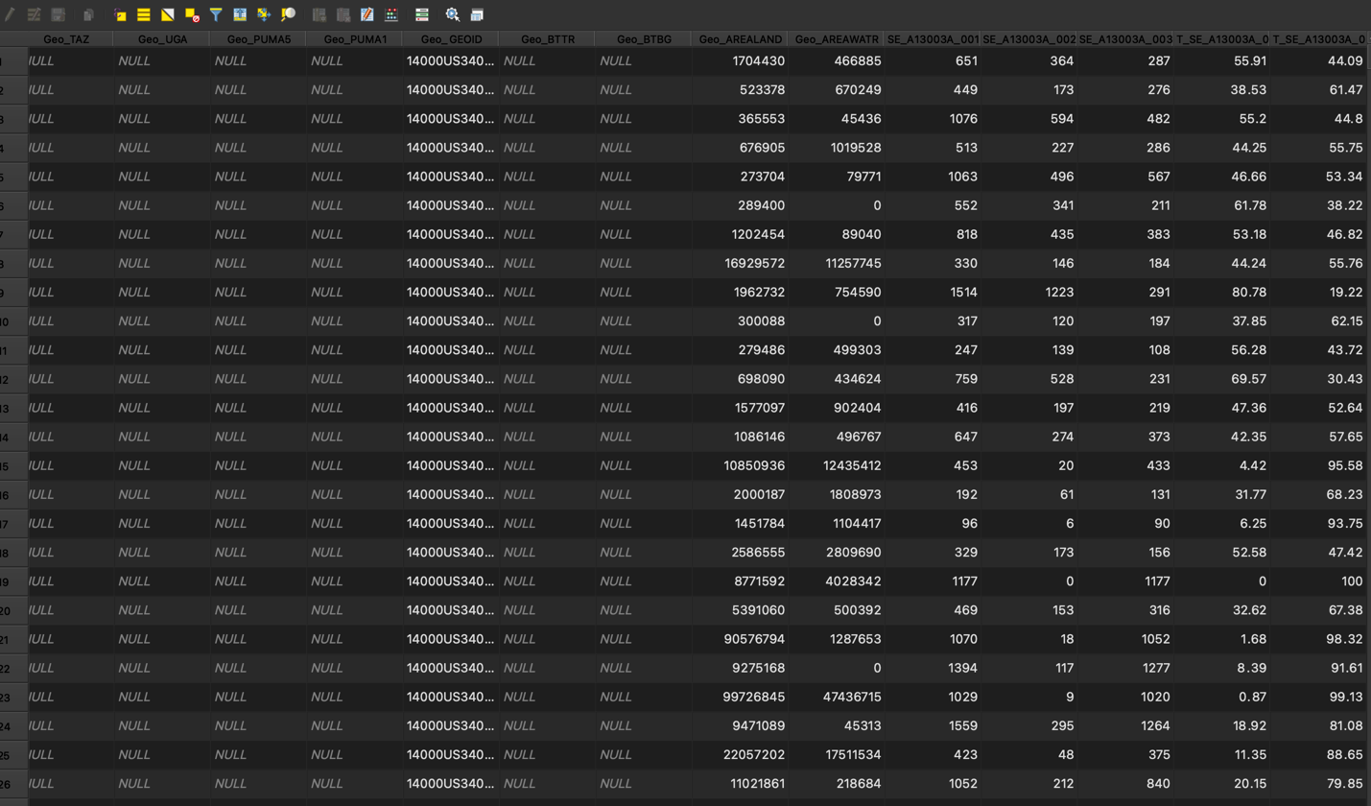

- Perform the Spatial Join:
  - Right-click on the merged census tract layer in QGIS and select Properties.
  - Navigate to the Joins tab and click the + button to create a new join.
  - Select the poverty data CSV or table as the join layer.
  - Choose the FIPS code column in both layers (from the merged shapefile and poverty data) to join on.
  - Complete the join to associate poverty rates with each census tract in New York, New Jersey, and Connecticut.

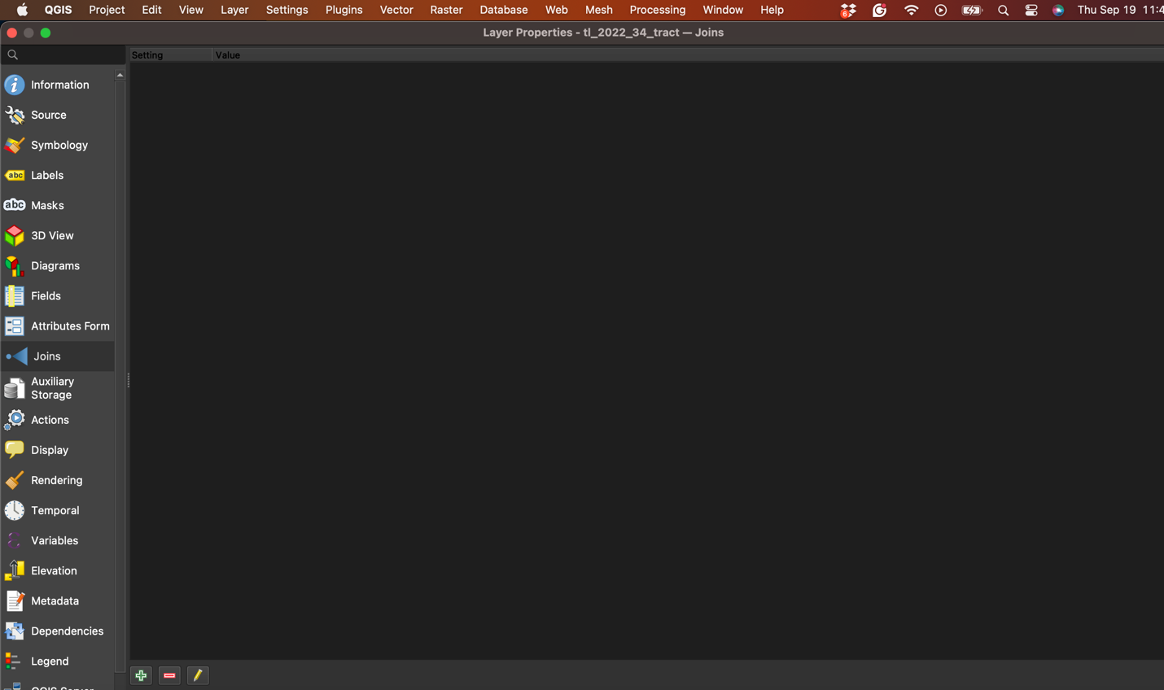
Click the “+” on the join feature to open the window to the join the CSV to the shapefile.

- Verify the Join:
  - Open the attribute table of the merged census tract layer.
  - Confirm that poverty rates have been correctly joined to the corresponding tracts.
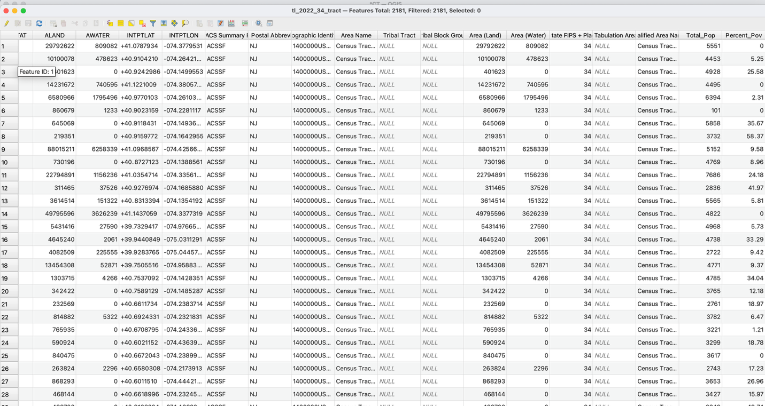

Part 3: Change the Missing Values:
- Open the Attribute Table:
- Right-click on the layer in the Layers panel.
- Select Open Attribute Table.
- Open Field Calculator:
- In the Attribute Table, click on the Field Calculator icon (looks like an abacus) or go to Layer > Open Field Calculator.
- Create a New Field:
- If you want to create a new column with NULL values replaced by 0:
  - Check the option Create a new field.
  - Set the Output field name (e.g., New_Field).
  - Choose the Output field type (Whole number (integer) or Decimal number (real) depending on your data).
- If you want to update the existing column:
  - Uncheck the Create a new field option.
  - Select the field you want to update.
  - Click on the “Fields and Values” to see the “field_name.” You should see something like "Percent_Pov"

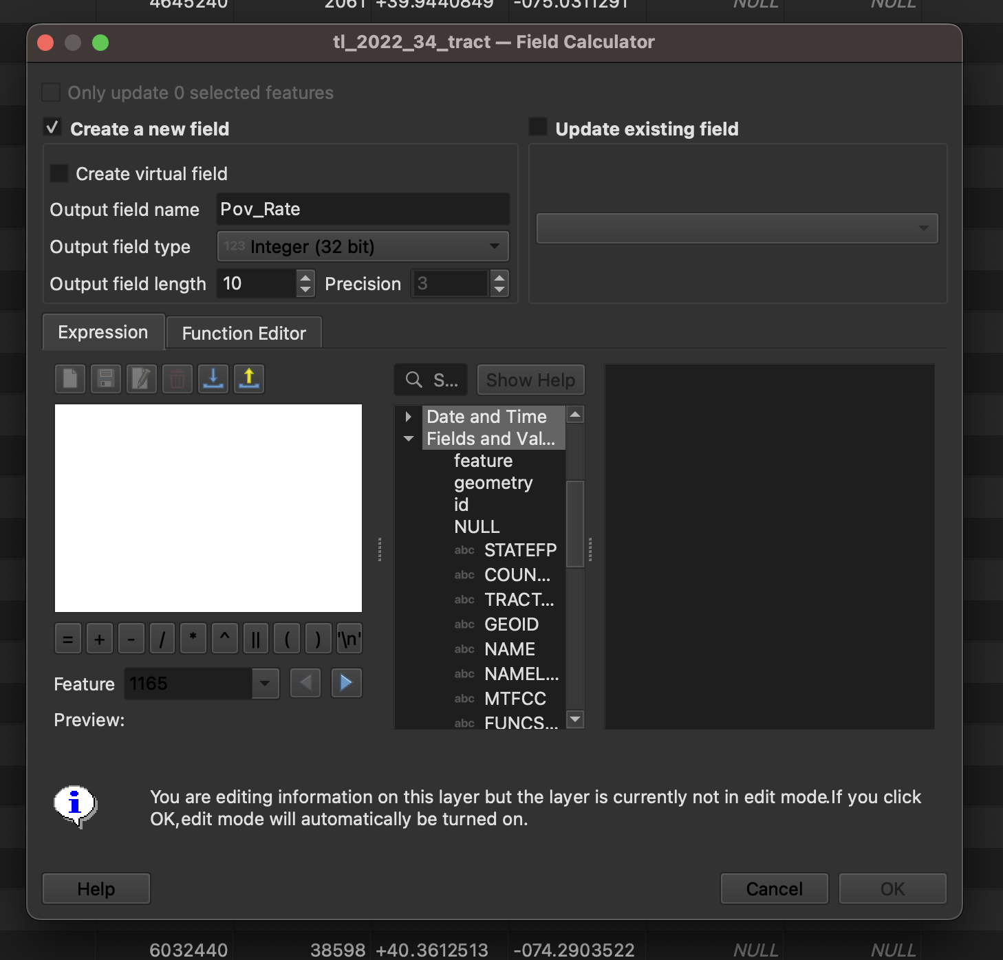
- Write a Conditional Expression (CASE WHEN):
- Use the following “expression” to replace NULL values with a non-zero, negative number because we do not want to put zero if there is no zero in the data unless we are positive which is usually not the case (we might want to also do a negative number like -4 or a way to know they are missing instead)
- Put code in the expression part: CASE WHEN "Percent_Pov" IS NULL THEN -99 ELSE "Percent_Pov" END

This makes sure to check all cases where the variable is Null and to replace with -99. You can then label the -99 to zero as missing values when you do the print layout.
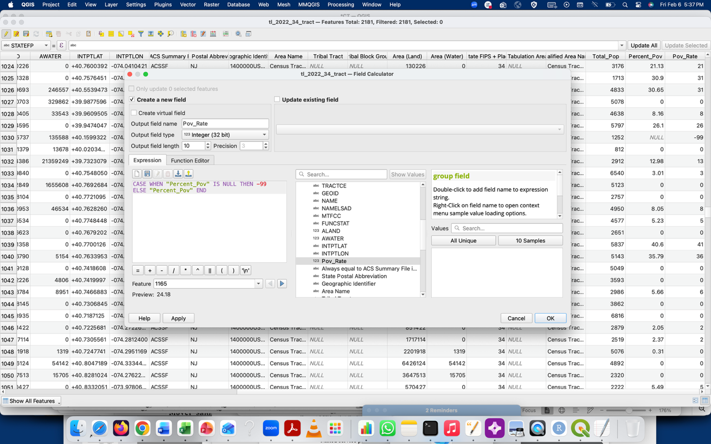

Part 4: Merging Census Tracts
- Merge Census Tract Shapefiles from the Three States:
  - Use Vector > Data Management Tools > Merge Vector Layers.
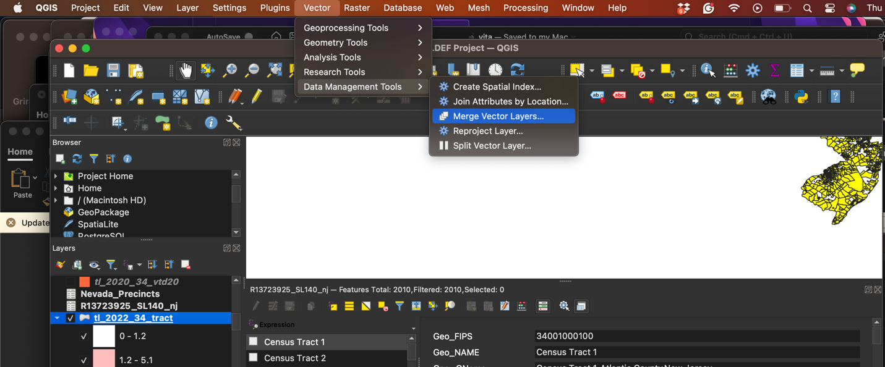
  - Select the census tract shapefiles for New York, New Jersey, and Connecticut. In the Merge Vector Layers dialog that opens:
  - For Input layers, select all the layers you want to merge. You can either select them manually from the drop-down or click on the … button and choose multiple layers from the list. Make sure to “click the checkbox” to the left of the layer.
  - Ensure all layers are in the same coordinate reference system (CRS). If they are not, you'll need to reproject them first, as QGIS cannot merge layers with different CRS.
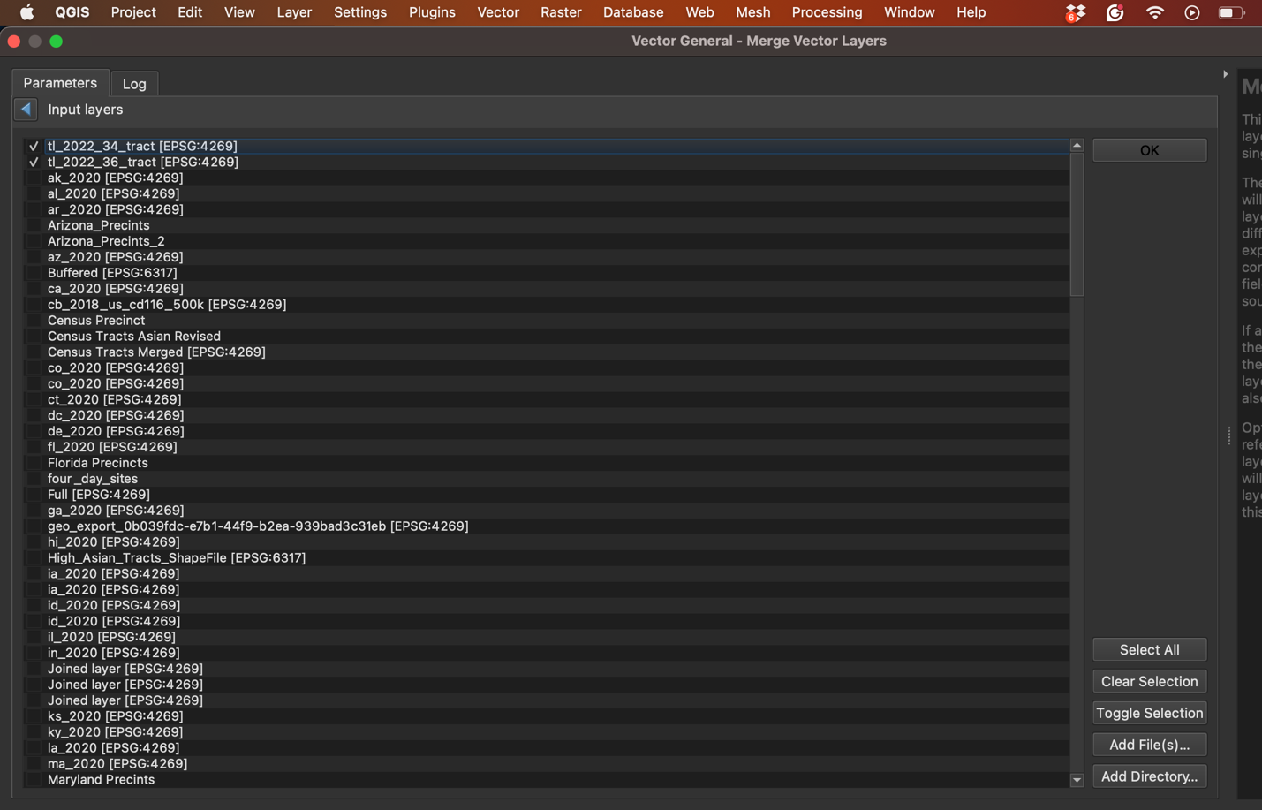
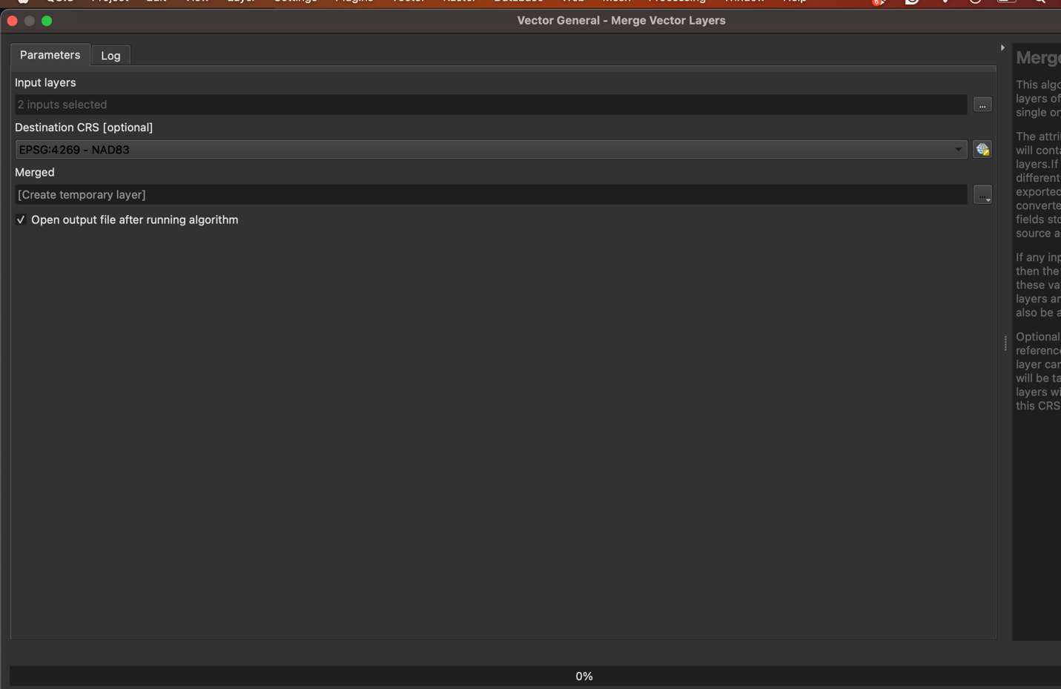
  - Choose the Output Location:
  - You can either leave the Temporary Layer option checked if you only want to preview the merged data, or:
  - Click the … next to the Merged field to save the merged output as a new shapefile or another format in a specific directory.
  - Give the output file a name (e.g., Merged_Tracts.shp) and select the appropriate file type (usually Shapefile).
  - Run the Tool:
  - Once the layers are selected and the output is set, click Run.
  - The tool will combine all the selected layers into one merged layer.
  - Check the Merged Layer:
  - After the process completes, the new merged layer will be added to your Layers Panel.
  - You can open the attribute table by right-clicking the merged layer and selecting Open Attribute Table to check that all the data from the original layers has been combined correctly.
  - Merge these into one unified shapefile. Name the output layer something like "NY_NJ_CT_merged_tracts."
  - Ensure that the merged layer includes tract-level FIPS and GEOID codes to be used in the next step for joining the poverty data.
- Inspect the Merged Tract Layer:
  - Open the attributes table to verify that census tracts from all three states are included.
Part 5: Visualization and Spatial Analysis (use Lab 1 and HW 2 strategies).
- Visualize Poverty Rates:
  - Style the map using Symbology.
  - Classify the new poverty rate into meaningful categories, such as quantiles, natural breaks, or custom thresholds.
  - Apply a color gradient to visualize the differences in poverty rates across the tri-state area.
- Analyze Spatial Patterns:
  - Identify any regional trends or clusters in poverty rates across New York, New Jersey, and Connecticut.
  - Describe whether certain areas show higher poverty rates and what geographic features (e.g., proximity to urban centers, state borders) might explain these patterns.
Part 6: Exporting and Submitting Your Work
- Map Export:
  - Export the final map of poverty rates by census tracts as a PDF or image.
  - Make sure the map includes an appropriate title, legend, and scale bar.
- Submission:
  - Submit your final map to Lab 2 on Courseworks.

